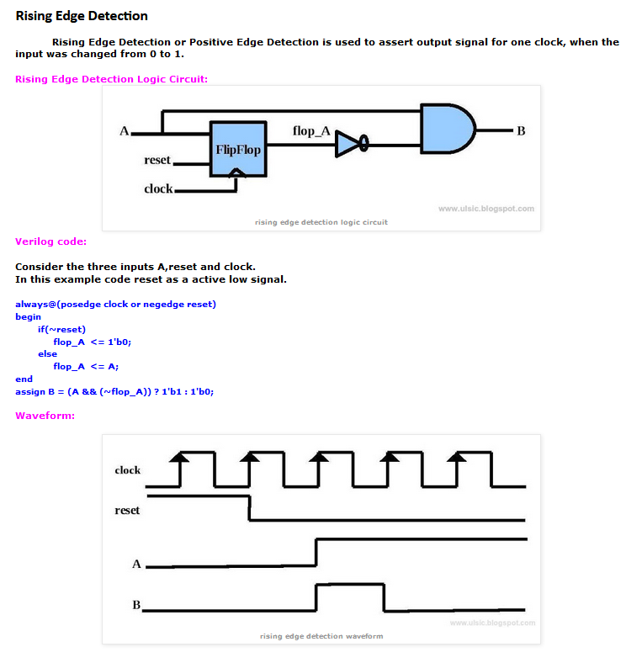
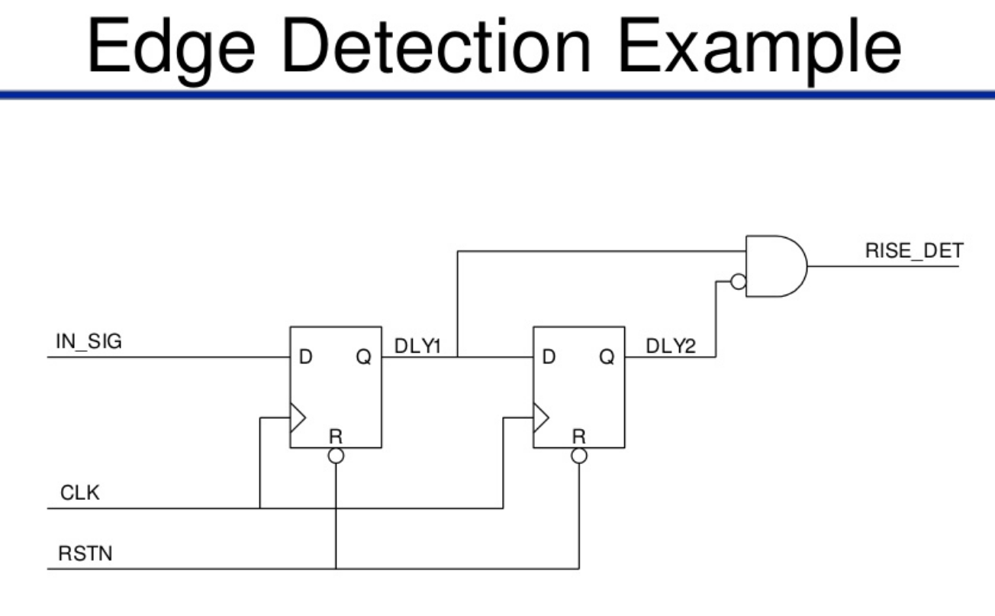
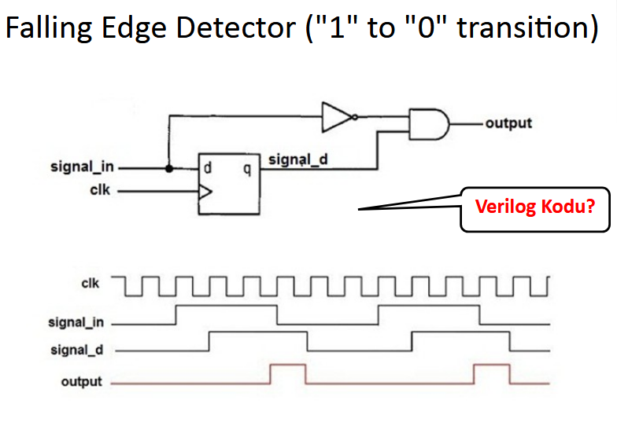
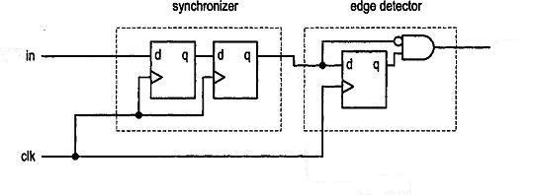
http://rtldigitaldesign.blogspot.fr/2014/06/pos-n-neg-edge-detector.html
http://www.fpga4student.com/2017/02/verilog-code-for-d-flip-flop.html
https://www.boldport.com/blog/2015/4/3/edge-detect-ad-nauseam super

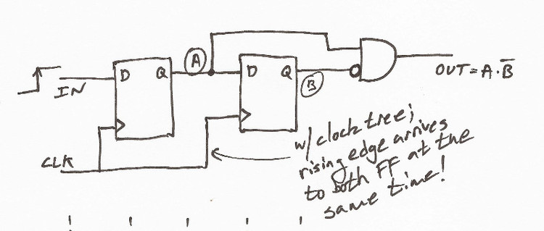
// edge detect module
module edge_detect(
input CLK,
input RST,
input IN,
output OUT
);

reg a, b;

// the edge detect signal is (b AND (NOT a))
assign OUT = a & !b;

always @(posedge CLK) begin
// It's always good to have a reset condition, otherwise
// the state of the register will show up as undertemined
// in simulation ('x')
if (RST == 1'b1) begin
a <= 0;
b <= 0;
end
else begin
a <= IN;
b <= a;
end
end

endmodule

///// http://www.edaboard.com/thread14551.html
https://github.com/pConst/basic_verilog/blob/master/EdgeDetect.v

